Name - Gaurang A Raorane Div - D15A Roll no - 49 Batch - C

**Experiment - 8**

**Aim :-**  Recommendation system using Machine Learning .

**Theory:-**

A recommendation system is a type of machine learning application that predicts the preferences or interests of users for certain items or products. It analyzes patterns in user behavior and item features to make personalized recommendations. Recommendation systems are widely used in various domains such as e-commerce, entertainment, social media, and more.

Here's an overview of the theory behind building a recommendation system using machine learning, along with the concept of TF-IDF vectorization:

**Types of Recommendation Systems:**

* + **Content-Based Filtering:** Recommends items similar to those a user has liked or interacted with in the past, based on item attributes or features.
  + **Collaborative Filtering:**
    - User-Based Collaborative Filtering: Recommends items to a user based on the preferences of users with similar tastes.
    - Item-Based Collaborative Filtering: Recommends items similar to those a user has liked or interacted with in the past.
  + **Hybrid Recommendation Systems:** Combine multiple recommendation techniques to provide more accurate and diverse recommendations.

**TF-IDF Vectorization:**

* + TF-IDF (Term Frequency-Inverse Document Frequency) is a numerical statistic that reflects the importance of a word in a document relative to a collection of documents.
  + Term Frequency (TF): Measures the frequency of a term (word) in a document.



* + Inverse Document Frequency (IDF): Measures the importance of a term across a collection of documents.



* + TF-IDF Score: The product of TF and IDF, which reflects the importance of a term in a document relative to the entire corpus.



* + TF-IDF vectorization converts a collection of documents into a matrix of TF-IDF features, where each row represents a document and each column represents a unique term in the corpus.
  + TF-IDF is commonly used in text mining and information retrieval tasks, including building content-based recommendation systems.

**Building a Recommendation System:**

* + **Data Collection:** Gather user-item interactions (e.g., user ratings, purchase history) and item attributes (e.g., item descriptions, features).
  + **Data Preprocessing:** Clean and preprocess the data, handle missing values, and encode categorical variables.
  + **Feature Engineering:** Extract relevant features from the data, such as user preferences, item attributes, or user-item interactions.
  + **Model Selection:** Choose an appropriate recommendation algorithm based on the type of data and problem requirements (e.g., content-based, collaborative filtering).
  + **Model Training:** Train the recommendation model on the historical data, optimizing for accuracy or other relevant metrics.
  + **Evaluation:** Assess the performance of the recommendation system using evaluation metrics such as precision, recall, or mean squared error.
  + **Deployment:** Deploy the trained model in a production environment, integrate it with the application or platform, and continuously monitor and update the recommendations based on user feedback and new data.

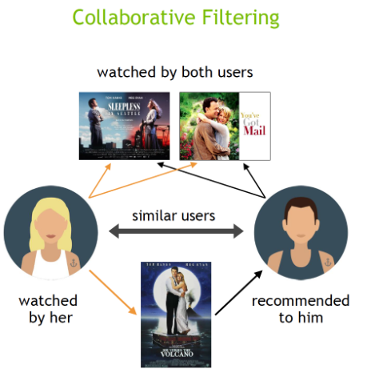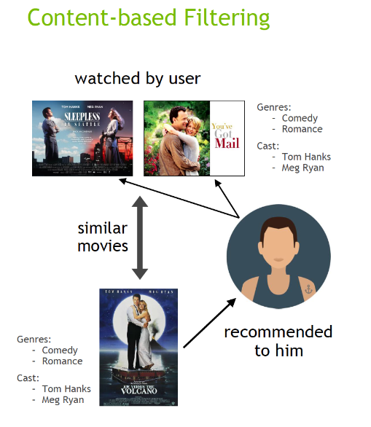

Input:-

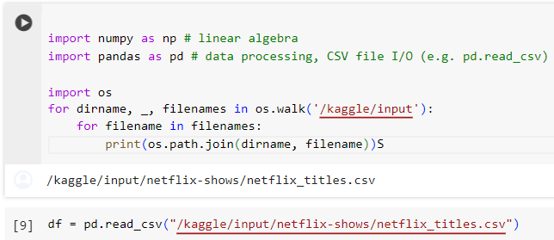

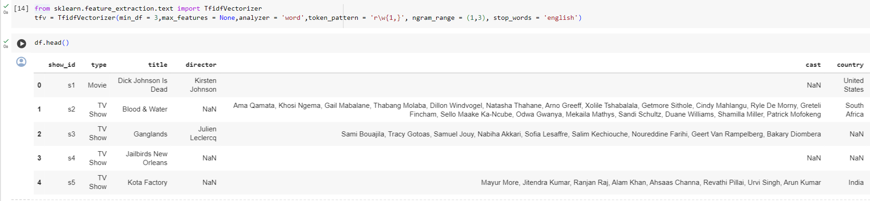

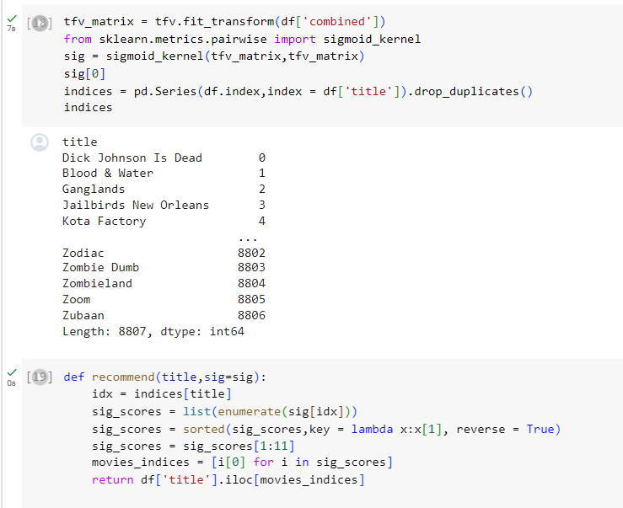

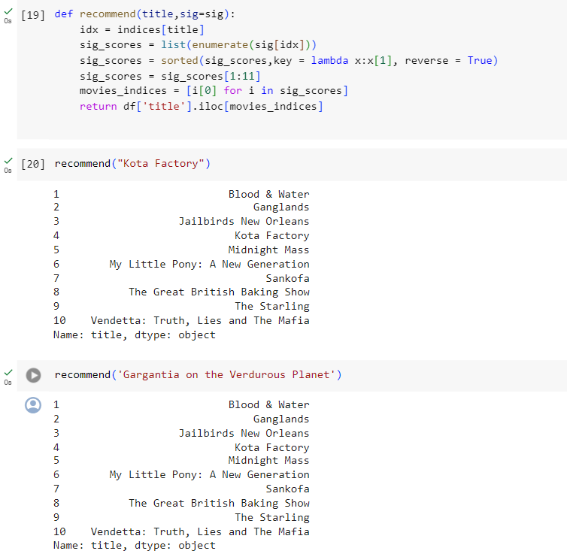

**Conclusion:-** Through this experiment we understood what recommendation systems are, and how to make one using cosine similarity.